Personal Diary

* 8th May 2014: Alex, Mathu and I made adjustments to the GDD, whilst Anthony worked on the TDD.
* 7th May 2014: Today I carried on working on the GDD, but I also asked the others for help with the contents of the TDD. I further created the IDD, which contains the game controls and small description of the interface during the loading process.
* 4th May 2014: Today I did some research on the GDD and the TDD’s structure and contents; so that I could get an idea of what things we could add into the documents. For the next couple of days I will be working on expanding the GDD’s contents.
* 26th March 2014: I carried on with some more designs for the backgrounds of the terrain. I had a further discussion with Alex, Anthony and Mathu about what was left to do for the program, the main problems is getting the pickups to respond the way they should and apply different physics to each terrain.
* 19th March 2014: Today I started working on some new designs for background settings for the race track, also Alex and I had a chat about the different terrains and what settings would they each include. For the moment I have created Prototype Mountains for the icy terrain, and I have also created pyramids for the desert terrain. Alex and I also had a discussion on some of the changes to physics that needed to be done when the terrain changes. I included in our group documentation our chosen terrain types as they weren’t added in before. 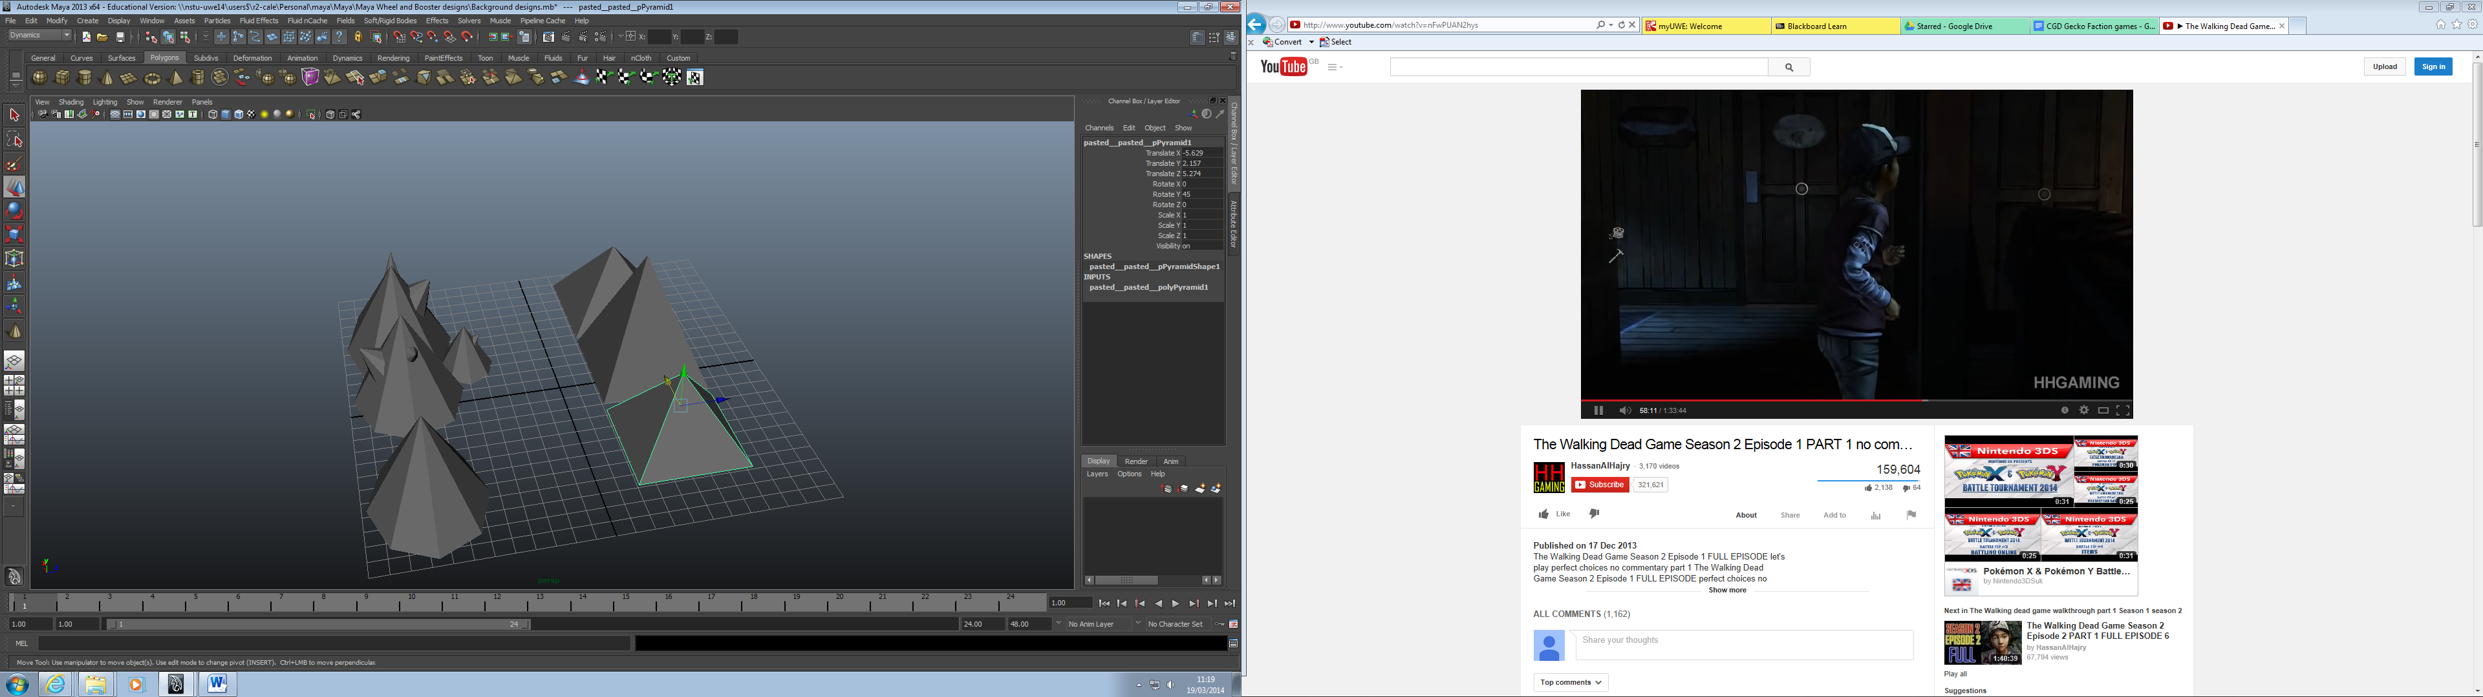
* 12th March 2014: I carried on with the designs for the boosters and wheels and added some comments to some empty spaces within the Game1 class of the main game. During the commission I left a message suggesting that it may be wise to add a bit more detail to some of the classes. 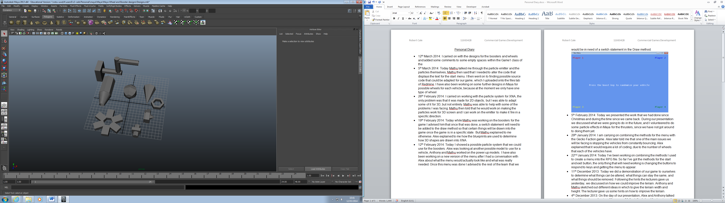
* 5th March 2014: Today Mathu talked me through the particle emitter and the particles themselves, Mathu then said that I needed to alter the code that displays the text for the start menu. I then went on to finding possible source code that could be adapted for our game, which I uploaded onto the files tab of Redmine. I have also been working on some further designs in Maya for possible wheels for each vehicle, because at the moment we only have one type of wheel
* 26th February 2014: I carried on working with the particle system for XNA, the only problem was that it was made for 2D objects, but I was able to adapt some of it for 3D, but not entirely. Mathu was able to help with some of the problems I was facing. Mathu then told that he would work on making the particles work for 3D screen and I can work on the emitter to make it fire in a specific direction.
* 19th February 2014: Today while Mathu was working on the boosters for the game I advised him that once that was done, a switch statement will need to be added to the draw method so that certain things will be drawn into the game once the game is in a specific state. But Mathu explained to me otherwise. Alex explained to me how the blueprints are used to determine how 3D shapes are drawn into XNA.
* 12th February 2014: Today I showed a possible particle system that we could use for the boosters. Alex was looking at another possible model to use for a vehicle, Anthony and Mathu worked on the power-up models. I have also been working on a new version of the menu after I had a conversation with Alex about what the menu would actually look like and what was really needed. Once this menu was done I advised to the rest of the team that we would be in need of a switch statement in the Draw method.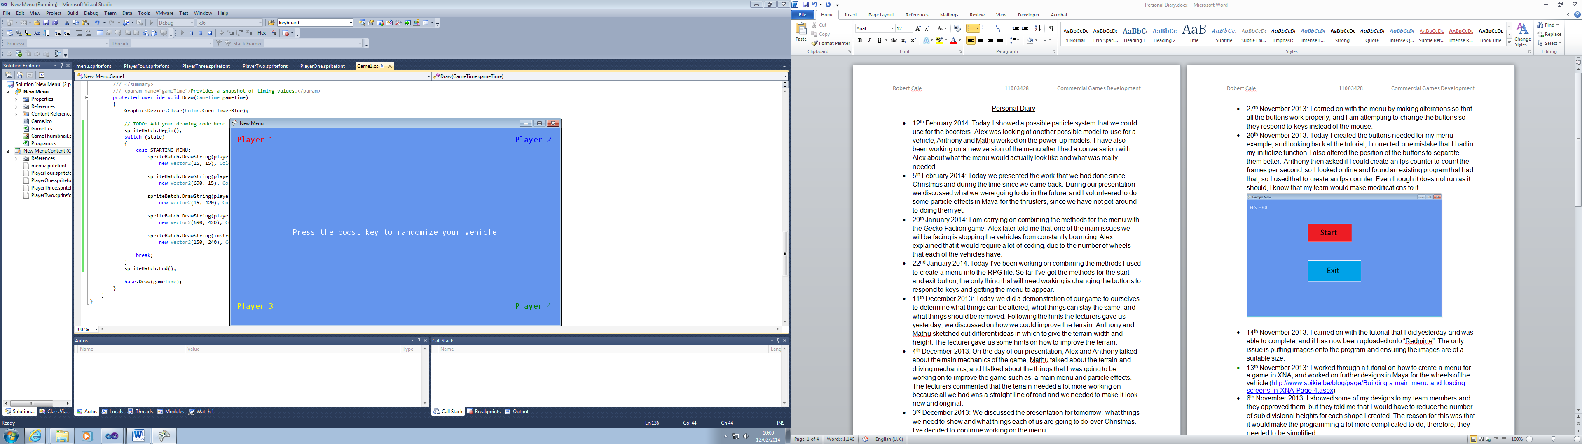
* 5th February 2014: Today we presented the work that we had done since Christmas and during the time since we came back. During our presentation we discussed what we were going to do in the future, and I volunteered to do some particle effects in Maya for the thrusters, since we have not got around to doing them yet.
* 29th January 2014: I am carrying on combining the methods for the menu with the Gecko Faction game. Alex later told me that one of the main issues we will be facing is stopping the vehicles from constantly bouncing. Alex explained that it would require a lot of coding, due to the number of wheels that each of the vehicles have.
* 22nd January 2014: Today I’ve been working on combining the methods I used to create a menu into the RPG file. So far I’ve got the methods for the start and exit button, the only thing that will need working is changing the buttons to respond to keys and getting the menu to appear.
* 11th December 2013: Today we did a demonstration of our game to ourselves to determine what things can be altered, what things can stay the same, and what things should be removed. Following the hints the lecturers gave us yesterday, we discussed on how we could improve the terrain. Anthony and Mathu sketched out different ideas in which to give the terrain width and height. The lecturer gave us some hints on how to improve the terrain.
* 4th December 2013: On the day of our presentation, Alex and Anthony talked about the main mechanics of the game, Mathu talked about the terrain and driving mechanics, and I talked about the things that I was going to be working on to improve the game such as, a main menu and particle effects. The lecturers commented that the terrain needed a lot more working on because all we had was a straight line of road and we needed to make it look new and original.
* 3rd December 2013: We discussed the presentation for tomorrow; what things we need to show and what things each of us are going to do over Christmas. I’ve decided to continue working on the menu.
* 2nd December 2013: On Skype, I learnt from Anthony and Mathu that we would be having a meeting tomorrow at 12 to put together the things we are going to present to the class on Wednesday 4th December. Furthermore, we discussed what things that each of us could do over Christmas and how that can be merged with the final product.
* 27th November 2013: I carried on with the menu by making alterations so that all the buttons work properly, and I am attempting to change the buttons so they respond to keys instead of the mouse.
* 20th November 2013: Today I created the buttons needed for my menu example, and looking back at the tutorial, I corrected one mistake that I had in my initialize function. I also altered the position of the buttons to separate them better. Anthony then asked if I could create an fps counter to count the frames per second, so I looked online and found an existing program that had that, so I used that to create an fps counter. Even though it does not run as it should, I know that my team would make modifications to it. 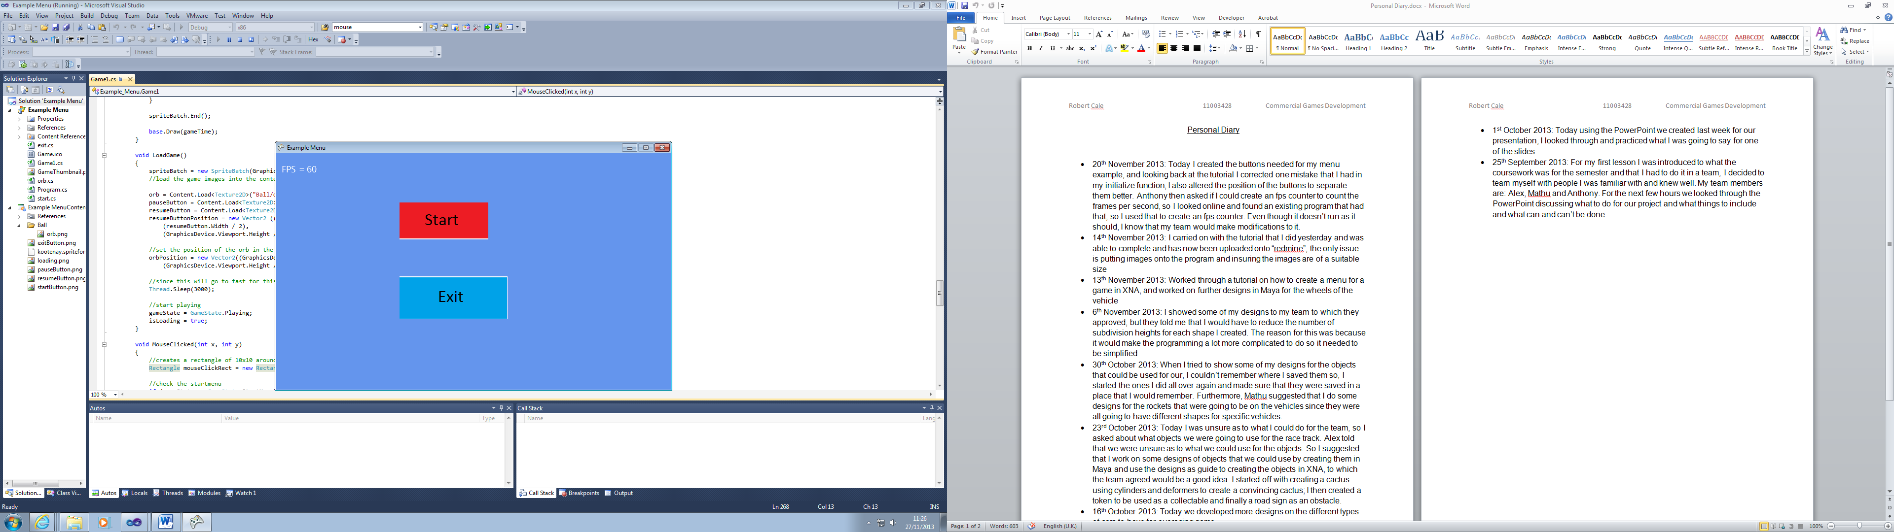
* 14th November 2013: I carried on with the tutorial that I did yesterday and was able to complete, and it has now been uploaded onto “Redmine”. The only issue is putting images onto the program and ensuring the images are of a suitable size.
* 13th November 2013: I worked through a tutorial on how to create a menu for a game in XNA, and worked on further designs in Maya for the wheels of the vehicle (<http://www.spikie.be/blog/page/Building-a-main-menu-and-loading-screens-in-XNA-Page-4.aspx>)
* 6th November 2013: I showed some of my designs to my team members and they approved them, but they told me that I would have to reduce the number of sub divisional heights for each shape I created. The reason for this was that it would make the programming a lot more complicated to do; therefore, they needed to be simplified.

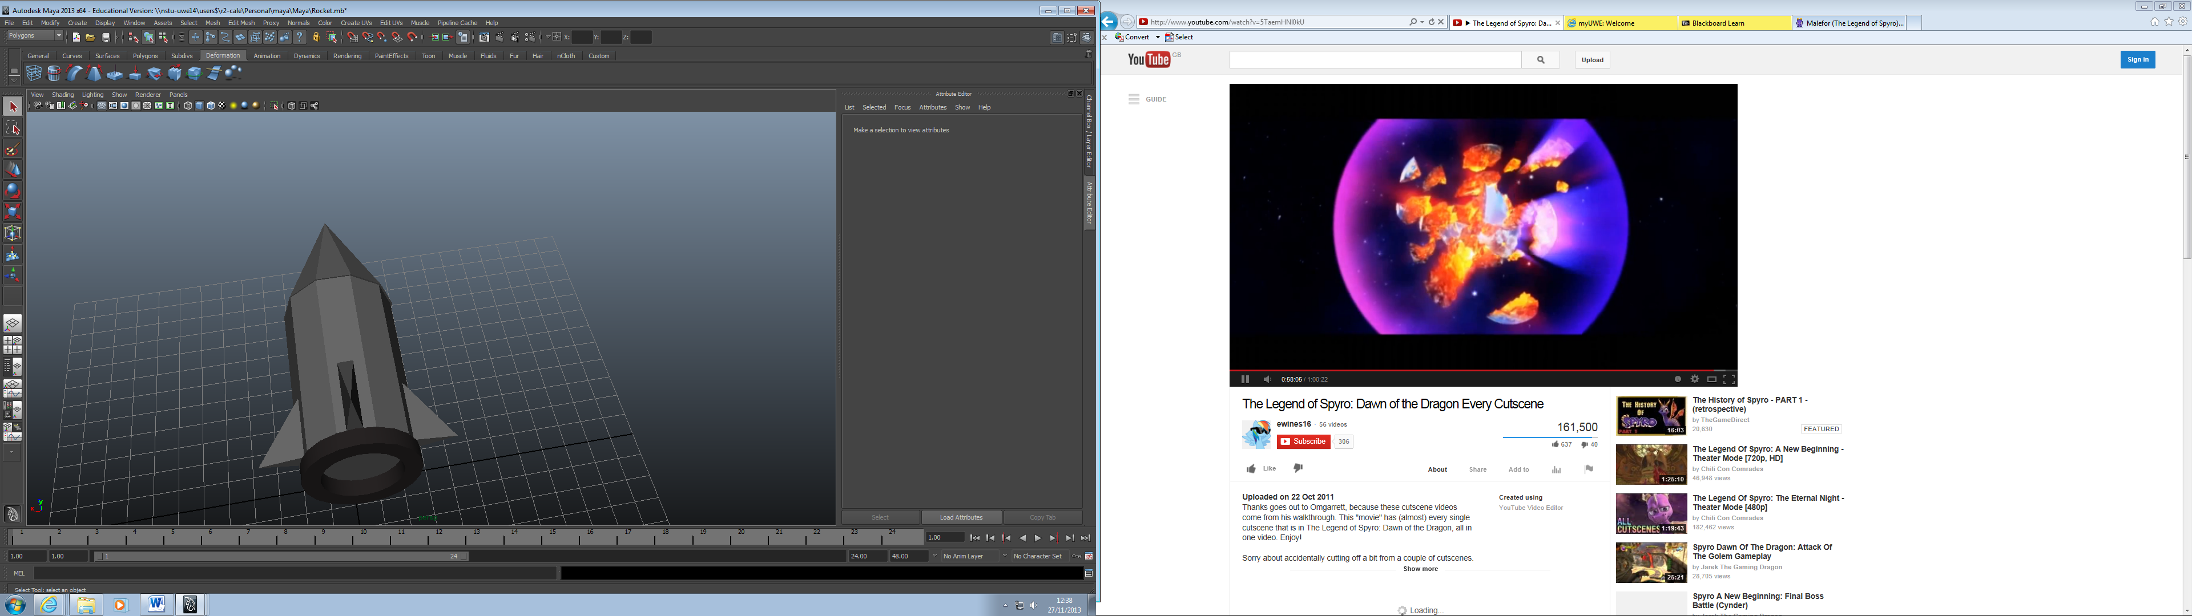

* 30th October 2013: When I tried to show some of my designs for the objects that could be used for our game, I could not remember where I saved them, so I started the ones I did all over again and made sure that they were saved in a place that I would remember. Furthermore, Mathu suggested that I do some designs for the rockets that were going to be on the vehicles since they were all going to have different shapes for specific vehicles.
* 23rd October 2013: Today I was unsure as to what I could do for the team, so I asked what objects we were going to use for the race track. Alex told me that we were unsure regarding what objects to use. So I suggested that I work on some designs of objects that we could use by creating them in Maya for us to have these designs as a guide to creating them in XNA, to which the team agreed would be a good idea. I started off with creating a cactus using cylinders and deformers to create a convincing cactus; I then created a token to be used as a collectable and finally a road sign as an obstacle.

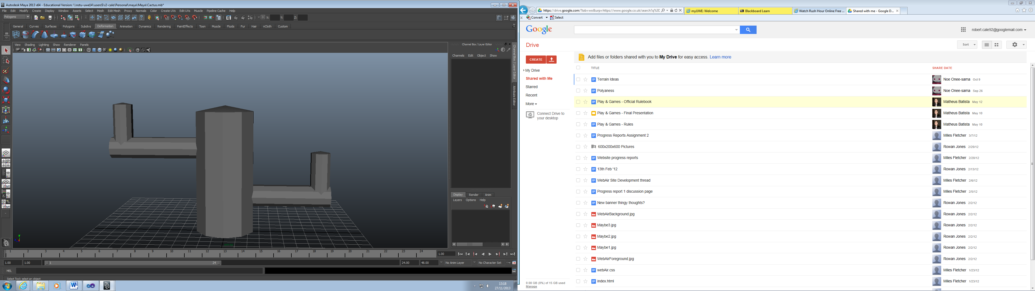

* 16th October 2013: Today we developed more designs on the different types of cars to have for our racing game.
* 2nd October 2013: Today we did our presentation on what we wanted to do for our game and received helpful advice from the lecturers on what we can also do and what we need to improve.
* 1st October 2013: Today using the PowerPoint we created last week for our presentation, I looked through and practised what I was going to say for one of the slides.
* 25th September 2013: For my first lesson I was introduced to what the coursework was for the semester and that I had to do it in a team, I decided to team myself with people I was familiar with and knew well. My team members are: Alex, Mathu and Anthony. For the next few hours we looked through the PowerPoint discussing what to do for our project, what things to include, and what can and cannot be done.